# TFS GIT Repository Using GITBASH Initial Setup

**Prerequisites:** Please refer to the DEVOPS_POC document and Proxy settings document**.**

**Step1: Clone the Empty GIT Repository**

Enter the URL in your browser,

<http://tfsprod.mtb.com:8080/tfs/DefaultCollection/nCino>

Get access to the Prod GIT repository by raising an access request or contact Sandeep Kompella.

Click/Hit the Code, it will navigate to the below page,

Copy the URL

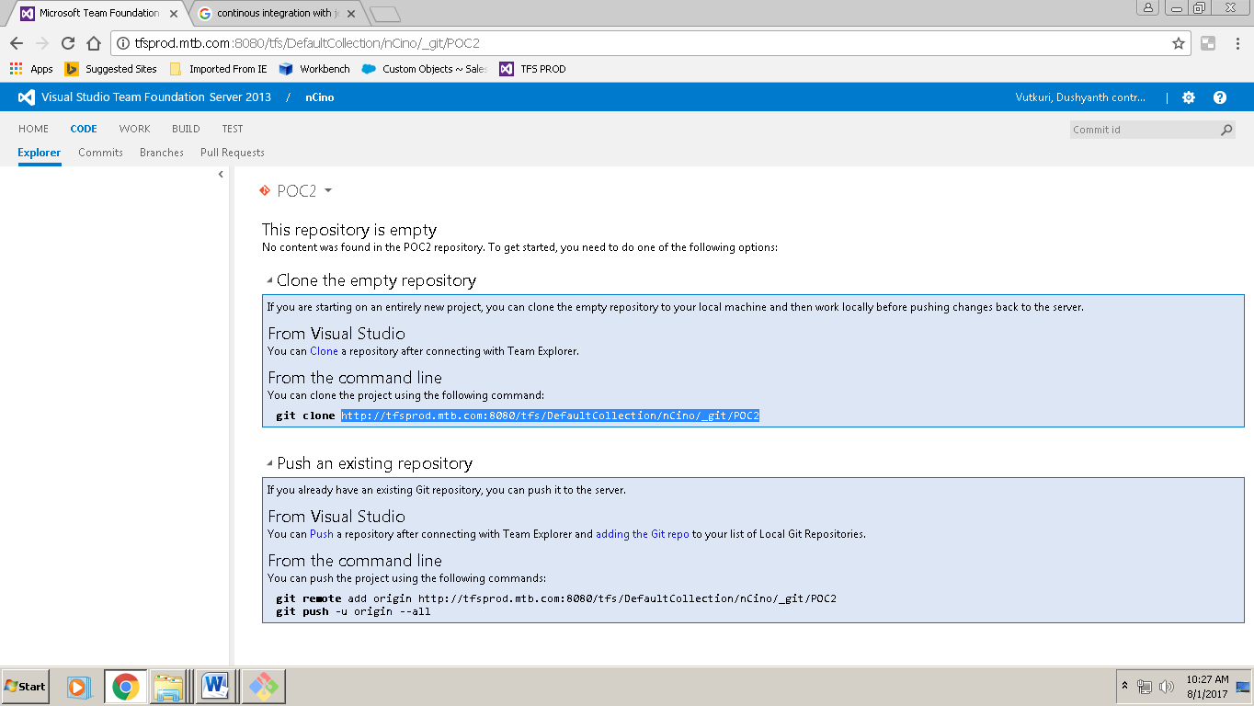

Open Command prompt and initialize the git, by running the below command,

**C:\Users\tglbdv3> git init**

Go to the GIT folder where you want to clone the repository - C:\Users\tglbdv3\git and open GITBASH

Run the command “**git clone (Repository URL)**”

**EX: git clone http://tfsprod.mtb.com:8080/tfs/DefaultCollection/_git/poc2**

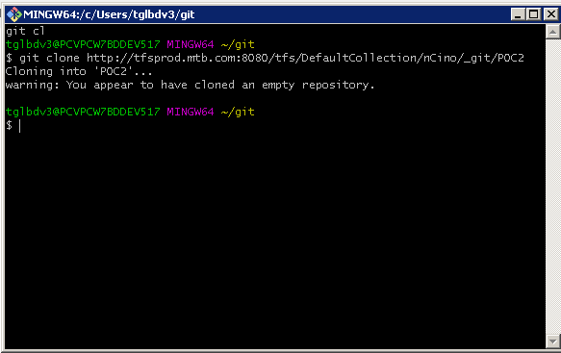

**Step 2: Share the Eclipse Project**

Open Eclipse -> Create a new Force.com Project, by providing your Sandbox credentials

Right Click on project>Team>share project

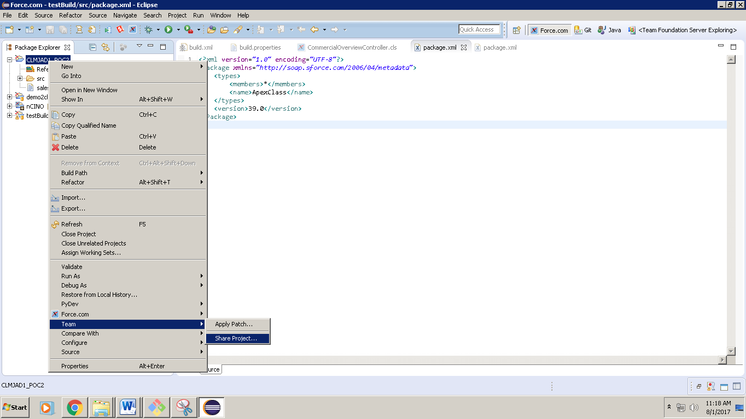

Select GIT

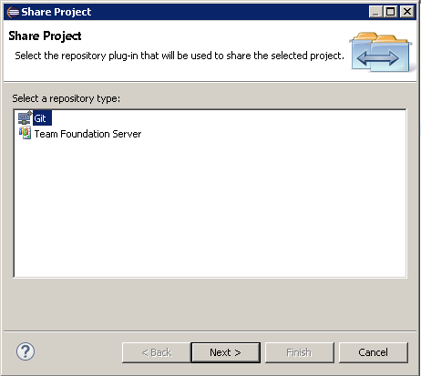

Click Create and choose the Repository from GIT folder you cloned earlier in the Step1 and click finish.

**Folder path: C:\Users\tglbdv3\poc2**

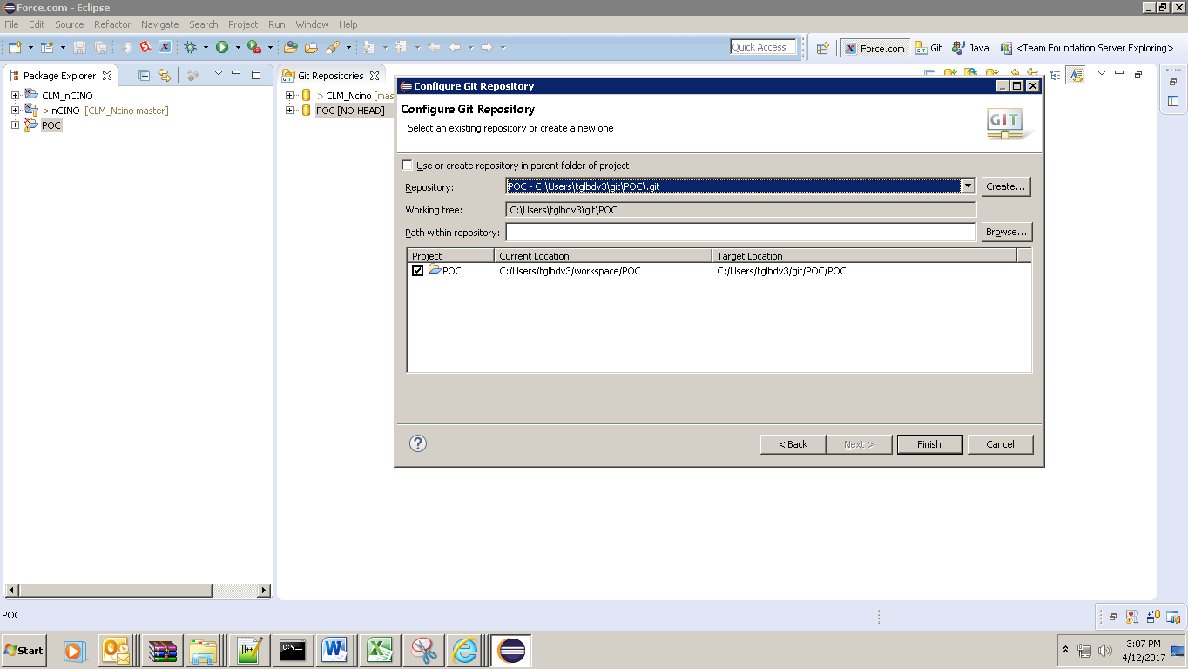

**Step 3: Code Commit and Push:**

Right click on project Team>Commit

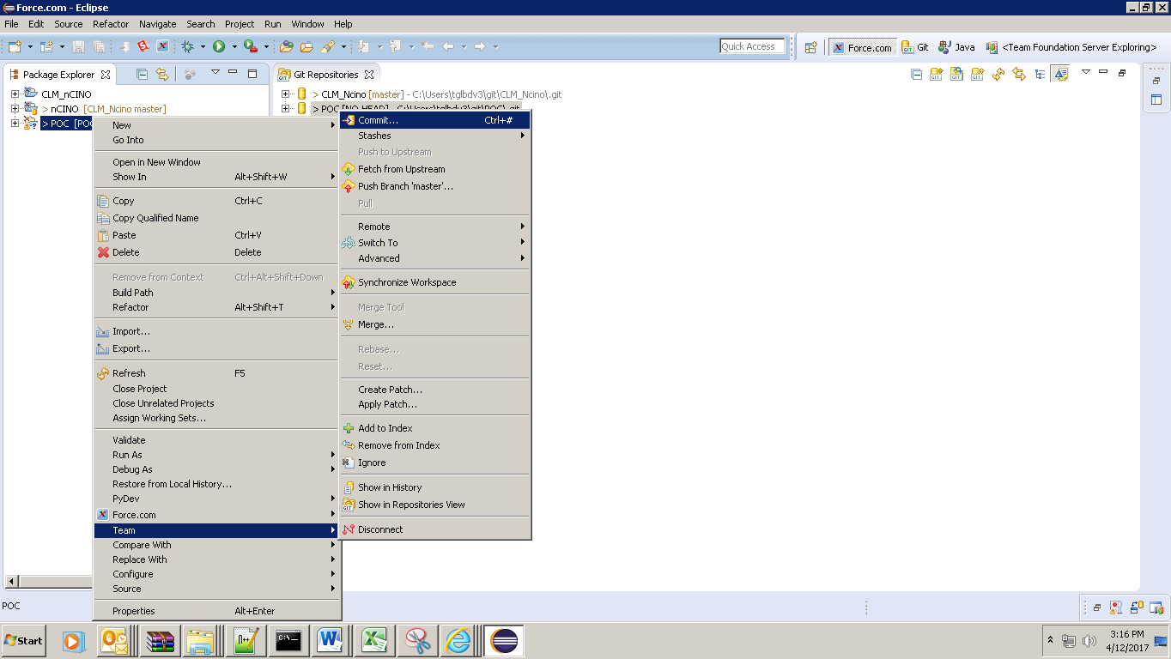

Select all and enter commit message. Code will be committed in local.

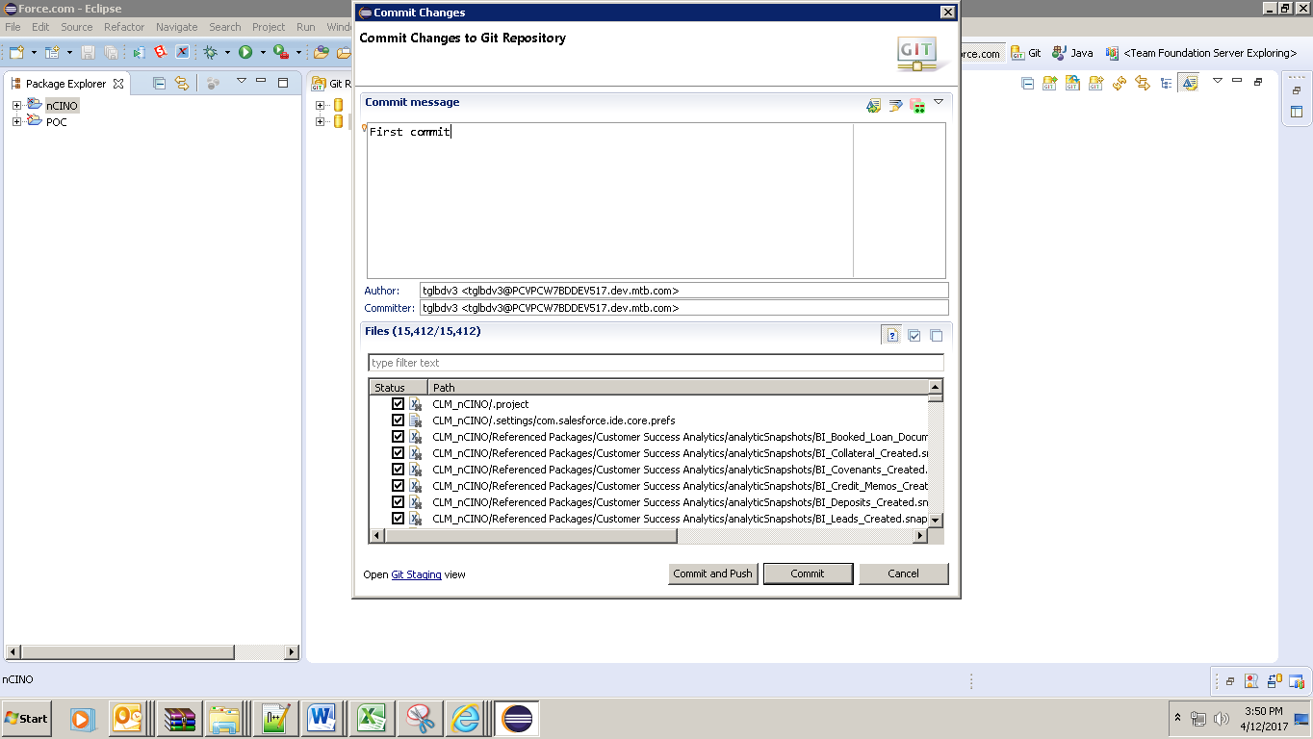

Push the code to TFS repository using GITBASH: Go to GIT Repository and open GITBASH

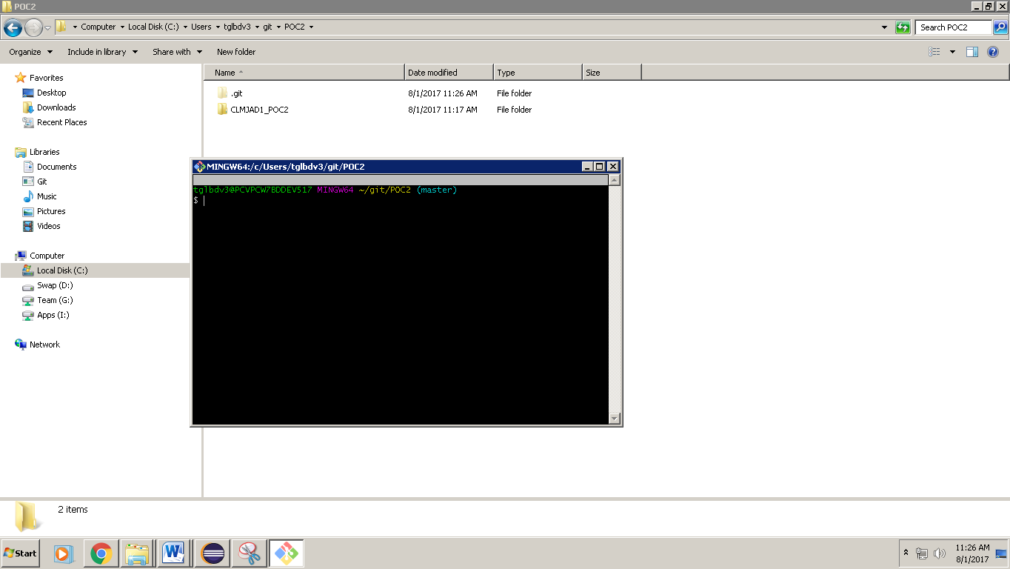

Run the command “**Git push origin master**”

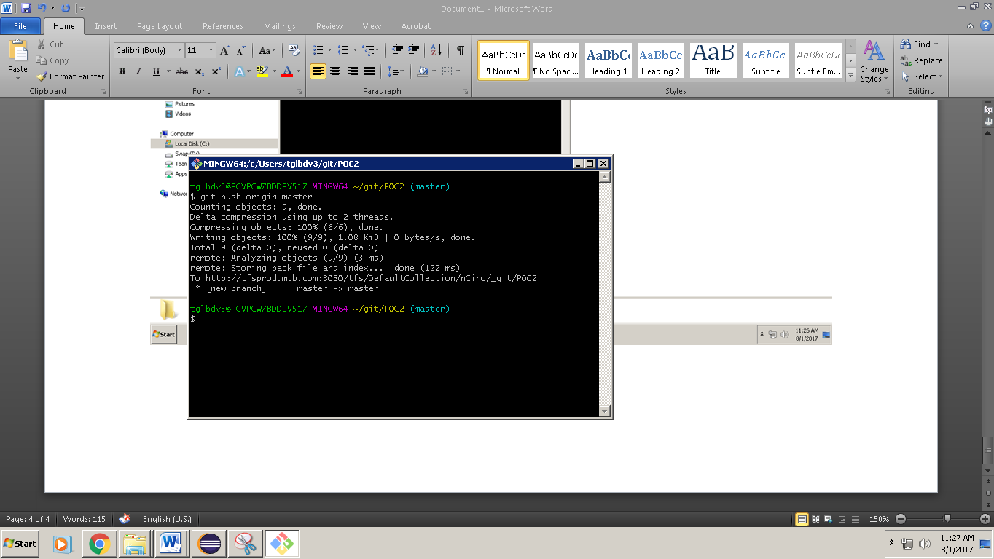

Check the TFS for CODE after successful push.

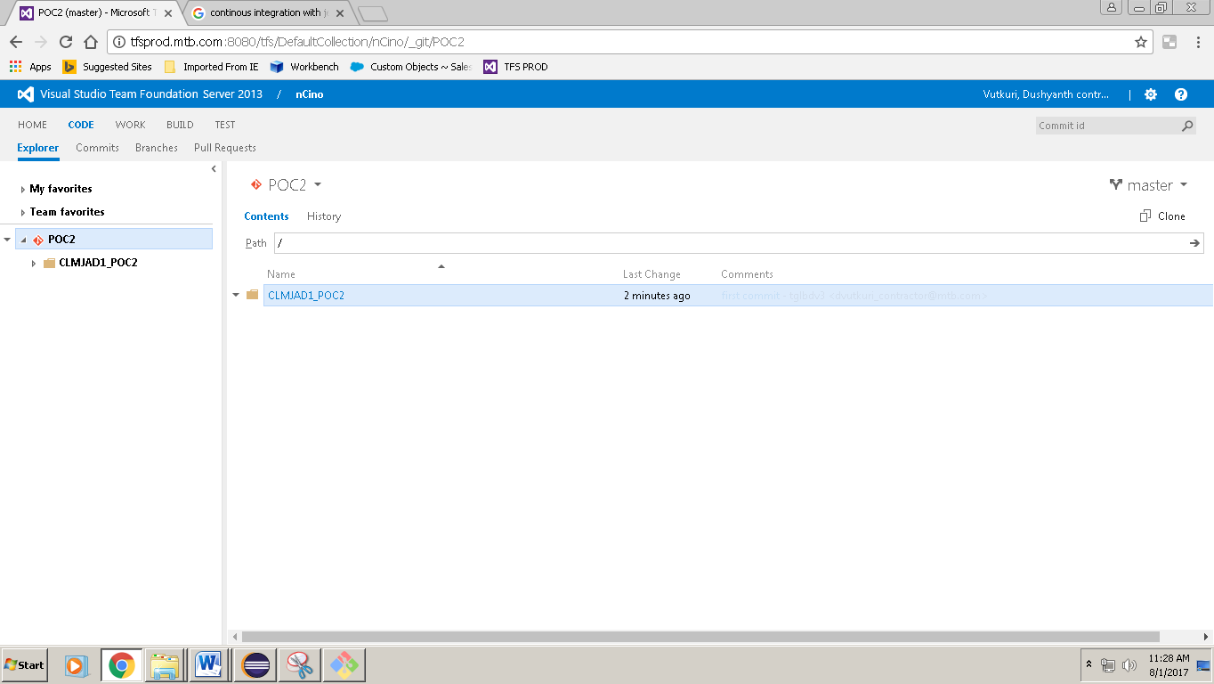

# Cloning an Existing Repository

**Step1: Clone an Existing GIT Repository**

Copy the URL 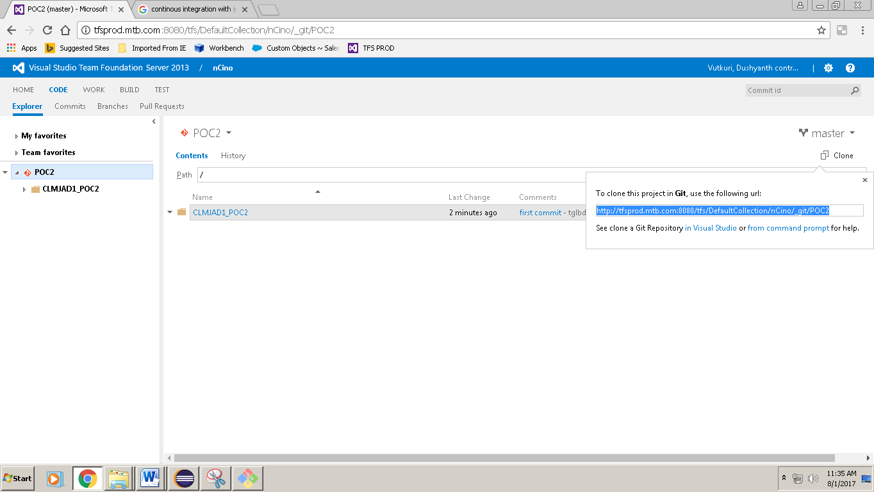

Initialize the Git using the below command, **git init**

Go to GIT folder where you want to clone the repository and open GITBASH, Run the command

git clone <http://tfsprod.mtb.com:8080/tfs/DefaultCollection/nCino/_git/POC2>

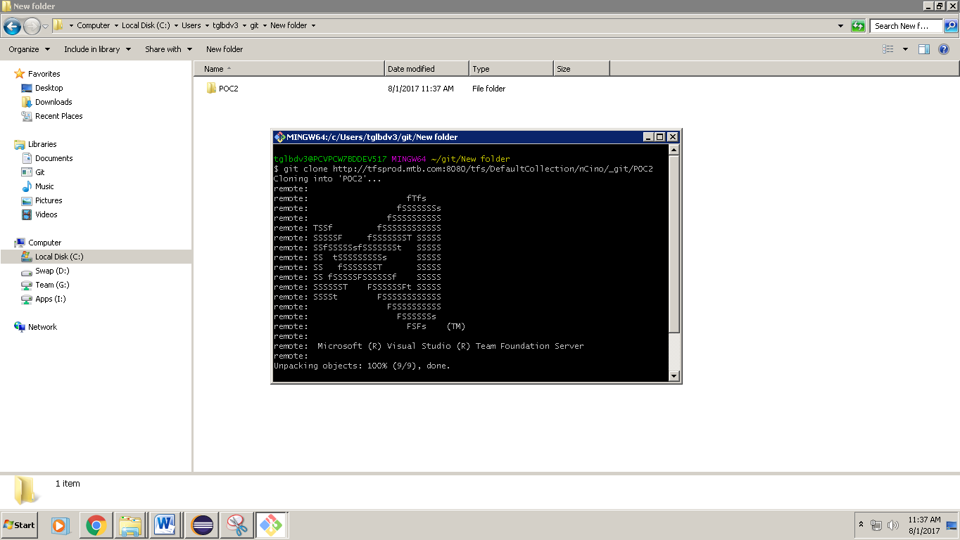

Now import this Git repository into Eclipse as a Project to continue working on it…

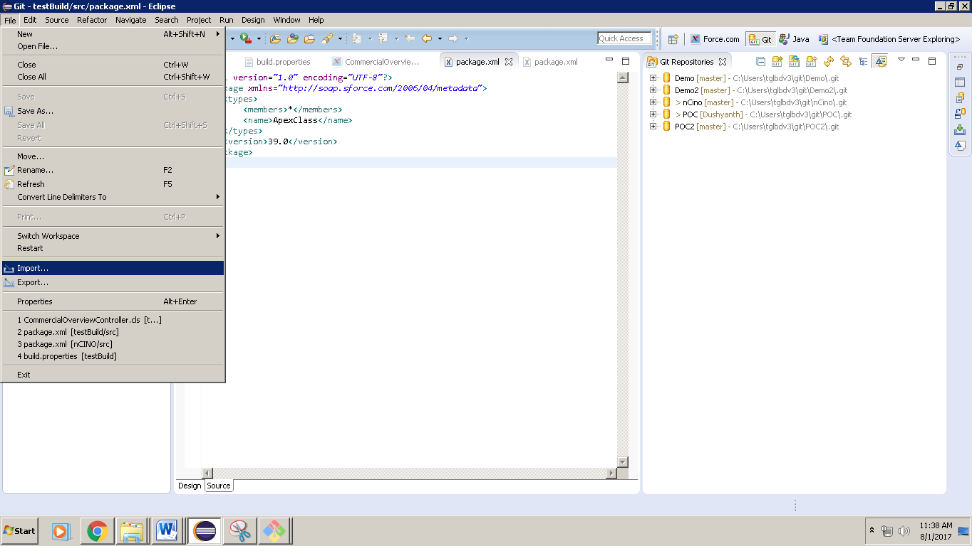

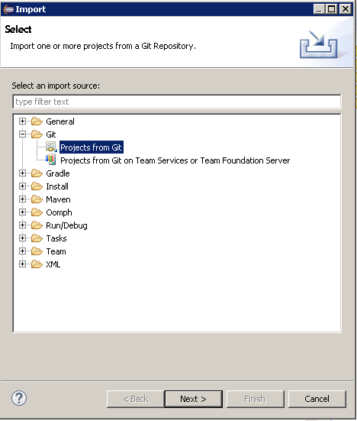

Select Existing Repository> select the GIT repository which you want to import and then click next>next>select the project and click finish.

